🎯 MicroGoals: A Comprehensive Technical Analysis of Secure Goal Management Systems
A RESTful Backend Architecture using Node.js, Express, and MongoDB

1. Abstract
The MicroGoals project represents a high-integrity backend infrastructure designed to solve the challenges of modern personal data management. In an era where data breaches are common, this system provides a blueprint for secure, user-isolated goal tracking. By leveraging a stateless authentication model via JSON Web Tokens (JWT) and a robust MVC (Model-View-Controller) architecture, MicroGoals ensures that user data is not only persistent but rigorously protected.

2. Project Overview & Vision
MicroGoals is more than just a task tracker; it is a secure gateway for personal productivity. Developed using the Node.js ecosystem, the API facilitates seamless user registration, authenticated login sessions, and full CRUD (Create, Read, Update, Delete) capabilities for goal management.

2.1 Core System Capabilities
- Identity Provisioning: Secure user onboarding with unique credential validation.
- Security Layer: implementation of industry-standard JWT for session persistence.
- Data Isolation: Strict middleware-enforced barriers preventing cross-user data access.
- Performance: Optimized MongoDB queries for low-latency interactions.

3. Project Foundations & Prerequisites
To ensure successful deployment and scalability, the following environmental prerequisites were established:
- Runtime Environment: Node.js (v18.0.0 or higher).
- Web Framework: Express.js for routing and middleware management.
- Database Engine: MongoDB (utilizing Atlas for cloud-native persistence).
- Development Tools: VS Code with the Thunder Client extension for rigorous API testing.

4. Comprehensive Project Architecture

4.1 High-Level Architecture Map
The system architecture is designed to decouple concerns, ensuring that the database logic is independent of the routing logic.

4.2 Technical Stack Breakdown
- Runtime: Node.js – Selected for its non-blocking I/O and event-driven architecture.
- Framework: Express.js – Providing a minimal, flexible foundation for RESTful APIs.
- Database: MongoDB – A document-oriented NoSQL database for flexible data modeling.
- Authentication: JWT – Enabling secure, stateless communication between client and server.
- Pattern: MVC – Separating Data (Model), Logic (Controller), and Routing.

5. Entity-Relationship (ER) Modeling
Data integrity starts at the schema level. We have implemented a relational-style mapping within a NoSQL environment.

5.1 Entity Definitions
- User Entity: Contains the primary identity of the account holder.
- Goal Entity: Contains the task data, linked via a specific reference to the User.

5.2 Relationship Mapping
The system utilizes a One-to-Many (1:N) relationship. A single user can possess numerous goals, while each individual goal is strictly owned by a singular user ID.
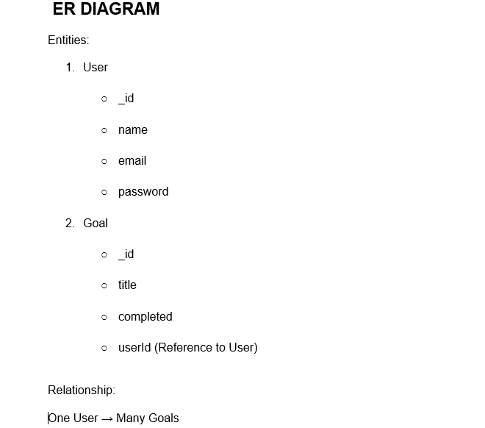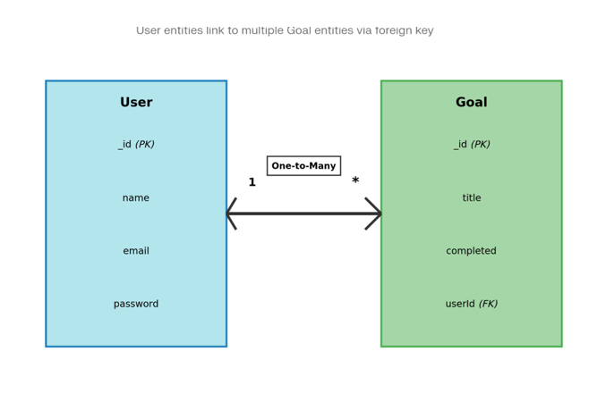

6. Functional Features & Security Philosophy

6.1 Authentication Mechanism
The authentication flow is built on the "Zero Trust" principle. No route is accessible without a verified signature.
- Bcrypt Hashing: Passwords undergo one-way cryptographic hashing before storage.
- Salt Rounds: Implementation of work factors to mitigate brute-force risks.

6.2 Goal CRUD Lifecycle
Users can interact with their data through four distinct operations:
- Create: Securely adding goals to the database.
- Read: Retrieving a filtered list of personal objectives.
- Update: Modifying the status or content of existing records.
- Delete: Permanent, authenticated removal of data.

7. Development Environment Setup
The development phase began with a clean environment initialization to ensure dependency stability.

7.1 Project Initialization
Using the command npm init, the project structure was defined, followed by the installation of core packages: express, mongoose, jsonwebtoken, and dotenv.
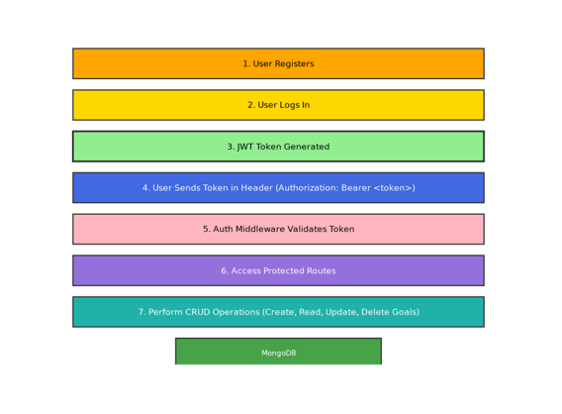

7.2 Package Configuration
The package.json file serves as the manifest for the system, defining entry points and automation scripts.
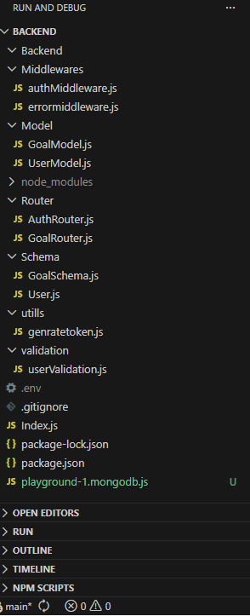

8. Backend Logic Implementation

8.1 Route Management
Routes act as the entry points for the API. Each route is mapped to a specific controller function that executes the business logic.
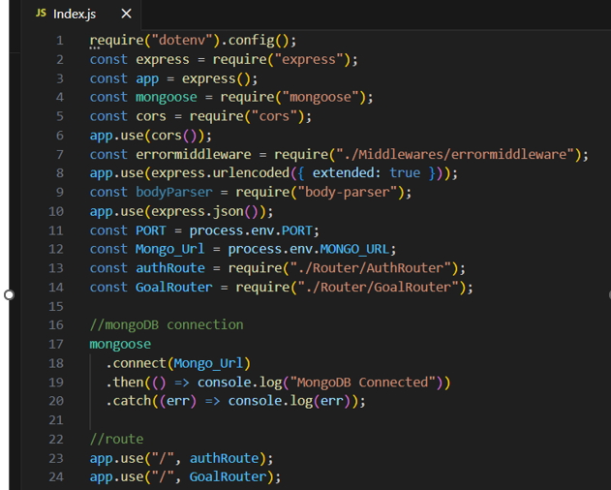

8.2 User Controller Logic
The controller handles the complex logic of comparing hashed passwords and generating tokens upon successful verification.
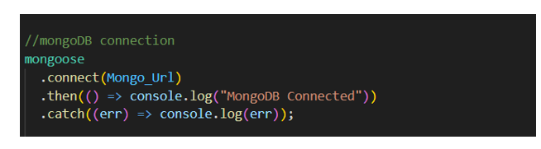

8.3 Goal Controller Logic
The goal controller manages the lifecycle of a task, ensuring that every operation is tied to the req.user.id extracted from the JWT.

9. Security Middleware Deep Dive

9.1 The 'Protect' Middleware
This custom function intercepts requests to the goal endpoints. It decodes the Bearer token and verifies its authenticity against the server's secret key.
const express = require("express");
const router = express.Router();
const goalModel = require("../Model/GoalModel");
const authmiddleware = require("../Middlewares/authMiddleware");

router.post("/create", authmiddleware, async (req, res, next) => {
try {
const { title } = req.body;
const goal = new goalModel({
title: title,
user: req.user,
});
await goal.save();
res.status(200).json({
success: true,
data: goal,
});
} catch (err) {
return next(err);
}
});

router.get("/:id", authmiddleware, async (req, res, next) => {
try {
const id = req.params.id;
const data = await goalModel.findOne({
_id: id,
user: req.user,
});
res.status(200).json({
success: true,
data: data,
});
} catch (error) {
return next(error);
}
});

router.put("/:id", authmiddleware, async (req, res, next) => {
try {
const goal = await goalModel.findOneAndUpdate(
{ _id: req.params.id, user: req.user },
{ completed: req.body.completed },
{ new: true },
);
res.status(200).json({
success: true,
message: "the goal is completed",
});
} catch (error) {
return next(error);
}
});

router.delete("/:id", authmiddleware, async (req, res, next) => {
try {
await goalModel.findOneAndDelete({
_id: req.params.id,
});

res.status(200).json({ message: "Goal deleted" });
} catch (error) {
next(error);
}
});

module.exports = router;

9.2 Centralized Error Handling
To prevent server crashes and sensitive data leakage (like stack traces), a custom error handler was developed to return clean, standardized JSON responses.

10. Database Configuration & Schema Design

10.1 MongoDB Integration
The system uses Mongoose to establish a reliable bridge between the Node.js server and the MongoDB Atlas cloud cluster.

10.2 Data Modeling
Schemas define the "rules" of the data. For instance, the User Schema requires a unique email, and the Goal Schema requires a valid user reference.

11. Project Execution & Validation
With the infrastructure in place, the project moved to the execution phase. This involved starting the server, connecting to the cloud, and performing end-to-end tests.

11.1 The Execution Workflow
- Initialization: Server startup via npm start.
- Handshake: Verification of successful MongoDB connection.
- Registration: Onboarding a new test user.
- Verification: Using the generated token to access protected data.

12. Output Results & Evidence

12.1 Successful Onboarding
The API successfully processes registration and login, returning a valid JWT.

12.2 Token Analysis
Detailed view of the JWT response structure used for authenticated sessions.

12.3 Data Persistence
Proof of successful data entry into the MongoDB cluster following an authenticated POST request.

12.4 Security Validation
Proof of the system's "Route Protection" in action, blocking access to unauthorized users.
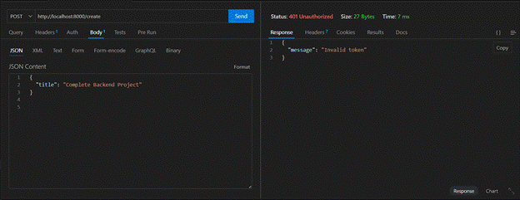

13. Project Conclusion & Future Roadmap
The MicroGoals API demonstrates a robust implementation of modern backend security and data management principles. By adhering to the MVC pattern and implementing rigorous authentication, the project provides a safe and scalable environment for personal productivity.

Future Enhancements
- Third-Party OAuth: Integration with Google and GitHub login.
- Frontend Dashboard: A React-based interface for visual goal tracking.
- Activity Logging: Detailed audits for user actions.

14. Demo Documentation
The project's functionality is verified in the accompanying demo video, which showcases:
- Real-time User Registration.
- Login and Token Retrieval.
- CRUD operations with database synchronization.
- Graceful handling of unauthorized access attempts.
Video Ref: Microgoal Video
Source Drive: MicroGoal(Backend)

